A New School for a New Start
By Jake Bowers

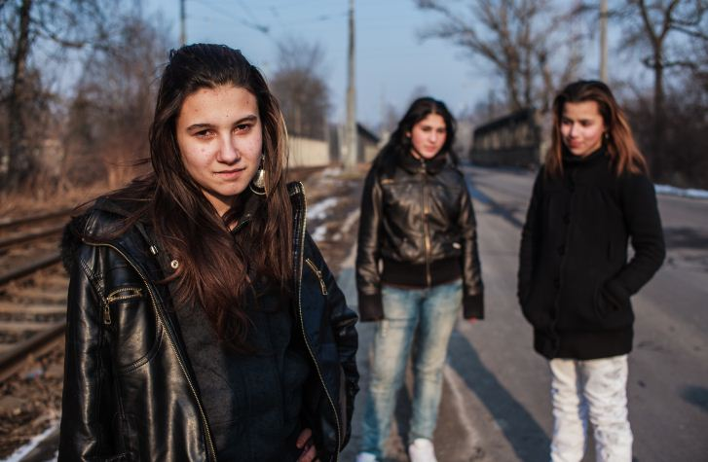
At the other end of the Czech Republic, in an environment a world away from the streets of industrial Ostrava, the Nová škola (or new school) Non Governmental Organisation (NGO) is bringing early years education to two socially excluded Romani communities deep in the Czech countryside.
Photo Courtesy of Simon Hipkins
Since 1996, they’ve supported inclusive education for minorities, foreigners and other socially disadvantaged groups. Having been instrumental in the introduction of Romani teaching assistants in primary schools, the organisation is now working beyond school institutions to take education to those who really need it most.
Jan Zajíc coordinates this project that brings early years education to Romani kids aged three and under who live in the Roma settlements of Dobra Voda and Nova Farma in the Karlovy Vary region of the Czech Republic. Both are former agricultural collectives made up of tenement blocks built in the 1960s. Public transportation to them is difficult and unemployment is high.
“We started with one main idea, which was to improve confidence between our communities,” says Jan. “We went to them and said ‘we need to trust each other. We know that you are good people and we have good intentions.”
Before beginning their work Nová škola did intensive research with the families and asked them about how they handled child nutrition, child rearing, and medical care, as well as the acquisition of language, motor and hygiene skills and personality development.
The answers they got are typical of any socially excluded community found anywhere in the world. The kids didn’t eat enough fruit and vegetables, nutrition got worse towards the end of the month, punishment was used more than rewards and they watched too much TV rather than reading. Also like any traditional community across the world, parental skills were also being passed from generation to generation, but traditional language was dying out.
“Each week we prepare a programme and about 12 or 15 children come,” says Jan. “We have taught, for example, the families about nutrition, that you don’t always have to eat meat. We have also talked about the importance of breast feeding. We have also talked about managing behaviour and not just using punishment. That there are many other ways of being a parent.”
One person who has been impressed by this approach is Zena Brabazon. She is a London based consultant who has spent much of her working life involved in early years education for the London Borough of Haringey, easily one of the most diverse urban communities in Europe. She has just seen the work of Nova Skola herself.
“These people may be poor,” she says, “but they are incredibly resilient and well informed. I don’t know if I could cope in the way that they do.”
Compared to the Sure Start children’s centres she has managed in inner city London she says the projects in the Czech Republic are very much in their infancy. You can tell she’s been shocked by the living conditions she’s seen there, but she’s also been impressed by the people she has met.
“You have to remember these are very small projects in housing settlements that have become ghettoised,” she says. “The projects have only been going for one year which is no time at all in early years education.”
Despite the comparisons between the highly polarised world of the Czech Republic, where Romani people are often the only visible minority, and the amazingly diverse streets of Haringey in London, she says the power of early years education to transform children’s lives is immense no matter where it’s practiced. She also agrees that it has enormous power to prevent segregation happening in the first place.
“All the research shows that good early years education gives children the best head start. A good qualified teacher can make a massive difference if the children have access to basic things like play, music, reading and literacy.”
But the research is one thing and the reality of life for Romani people across Eastern Europe is another. The sad fact is that for every Romani child that get’s early years education delivered by an NGO there are hundreds, thousands that currently do not.
Miroslav Sklenka has a view that puts all this great work into perspective. He’s not only a Roma man, but is well educated and deeply involved in providing early years education. He’s a technical adviser to the projects in the Czech Republic and runs his own early years project in Zar nad Hronem in Slovakia. He underlines the need for this work not only to continue, but to be radically extended.
“The main problem for all Roma communities is the cycle of poverty they are trapped in,“ says Miroslav. “But to break this cycle you have to have education. There is a good primary school system in the Czech Republic but beginning at the age of 5 or 6 is too late. So we have to start with early years education.“
I ask what might happen if the state took his suggestion and acted on it, would it really help tackle the deep segregation and racism that afflicts Romani communities? His answer is sobering. “ It‘s very hard to say, because we have only had NGO projects until now. From the ages of 0-3 there is nothing provided by the state. We might have involved maybe a 1000 children, but what about the 50,000 children that have nothing?“
Unlike many of his Romani peers, Miroslav concedes he was blessed. “I grew up in good conditions, I had parents that helped me get a good education.“ Most young Roma, he says, still leave school with no more than a basic primary school education, their potential forever constrained by a bad start and terrible policy. For now the system of segregated education that has condemned and even defined Romani kids as stupid is safe. Or as Miroslav puts it:
“There are Roma children who need special care. But 90% of the children that are there definately do not belong there.“
For Romani man Dr Adrian Marsh, Senior Programme Manager at Early Childhood Programme at the Open Society Foundation and driving force behind much of the organisation’s work to improve the education of Romani kids, the solution requires a fundamental change in thinking. He believes that ending the educational segregation of Romani children is about tackling institutional racism and promoting the concept of truly inclusive education.
“I discovered recently that the model most of these eastern European countries use to assess children is medical rather than educational,“ he says. “The tests are medically based. So if these kids have any medical problem at all they will simply be sent to special schools.“ By that yardstick, he points out, many of the world’s greatest minds would indeed have floundered.
But it is not, in his view, about debating whether any particular child should be sent to a special school, it’s about whether any chidren at all should go to a special school. Like disability rights advocates everywhere, he’d like to see the special schools not just deracialised but shut, for good.
“In the Czech Republic, and elsewhere, we need to reform the education system so that it is truly inclusive.“ Like many others he’d like to see the resources used on special schools spent on supporting children with special needs in a mainstream environment.
Like all those involved in improving Romani education he abhors the racist idea that being Romani is a disability in itself. “We have to ask, ‘why is it that so many Romani children are defined as disabled?‘ The answer is purely institutional racism.“
By definition, institutional racism needs a host in order to flourish, and if haven’t the power to remove it’s malignant power from the heart of Europe, the very least we can all do is support him in preventing our children encountering it in the first place.

